Lab 30 - Layer 2 DTP Attack
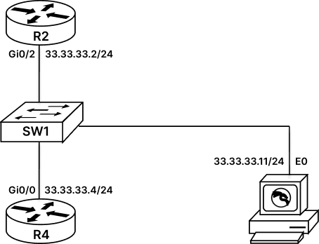

Configure Layer 2 DTP Attack
DTP stands for Dynamic Trunking Protocol, which is used by Cisco devices to form trunk between cisco switches. Using this trunk port Cisco Switches exchange the VLAN information across switches. By default, DTP is enabled on Cisco Switch and attacker can take advantage of this feature and can form trunk with Cisco Switches.
To do this attack we will use Kali Machine and inbuilt Layer 2 attack tool that is “Yersinia”. Yersinia is a framework that is used in Kali Machine to perform Layer 2 attack. In this LAB, we will be using this tool to perform DTP attack on our switch and will spoof our KALI machine as a switch to form trunk with our actual Switch.
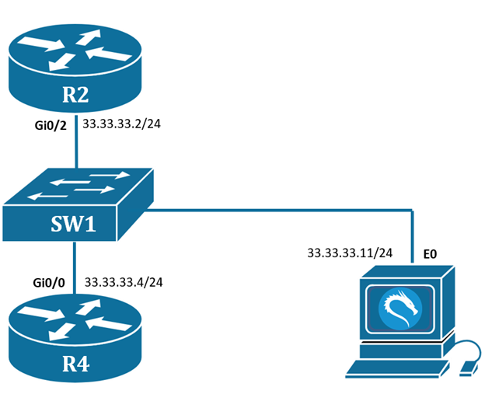
Task 1: Perform DTP Attack on Cisco Switch
Step 1: To start with this lab, we will go to switch and verify if there is any kind of trunk on switch.
SW1#sh interface trunk
SW1#
SW1#
Step 2: We will take access of kali machine
username : root
password : rst@12345
From kali machine open terminal and type ‘yersinia -G’.
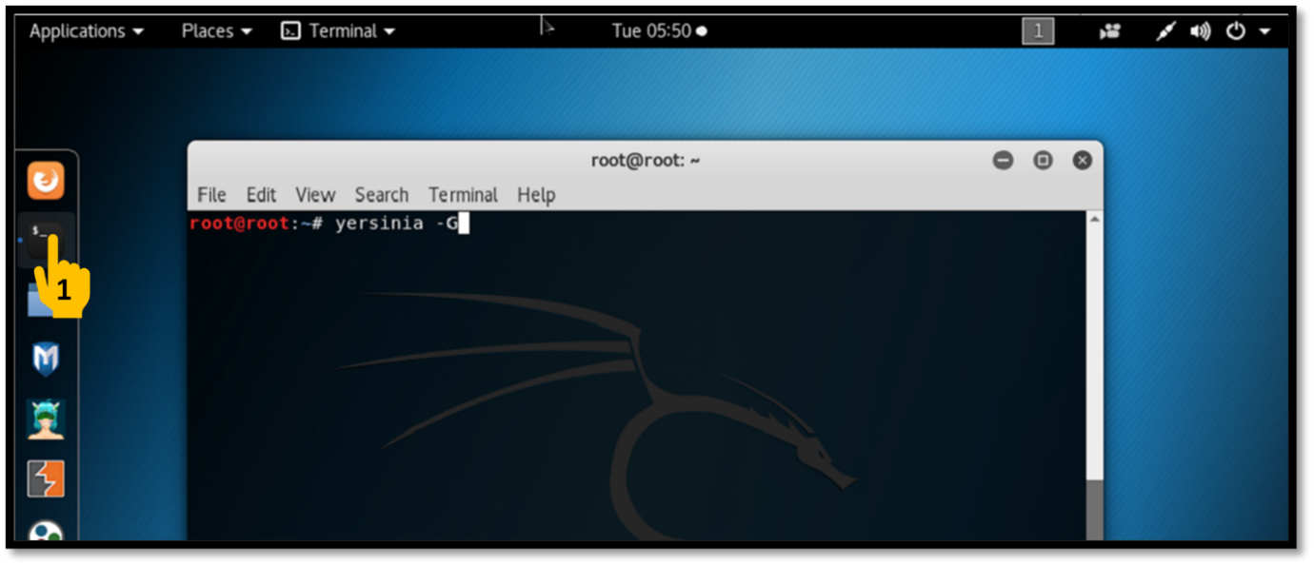
Step 3: After opening up yersinia we would get a notification stating its an Alpha Version, this can be ignored. Now we will click on DTP tab and after some time we will see our switch sending DTP packets.
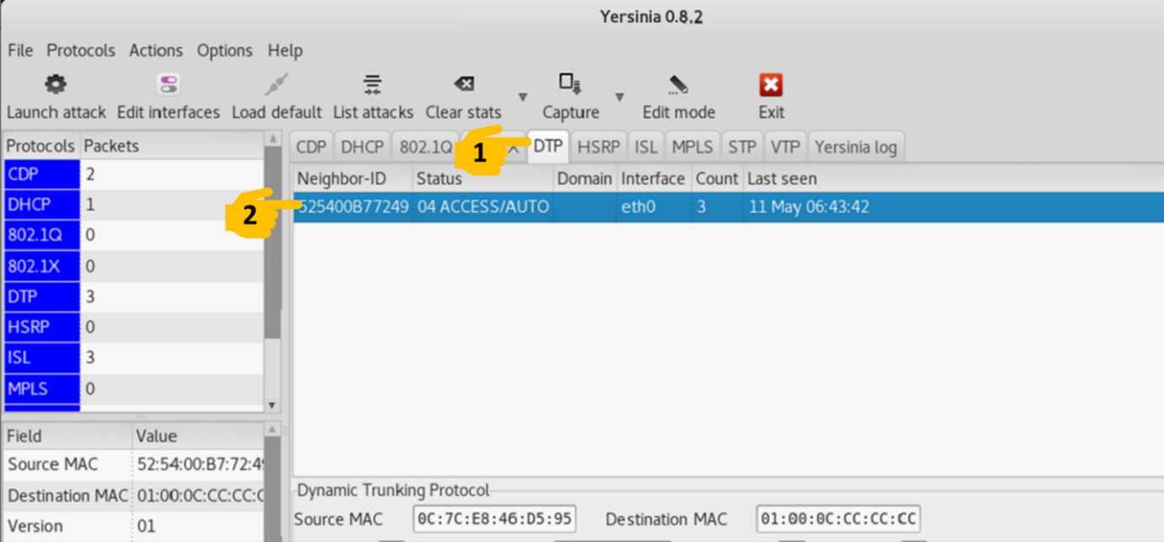
Step 4: Now we will start attack, by clicking on Launch Attack and then selecting “enable Trunking”.
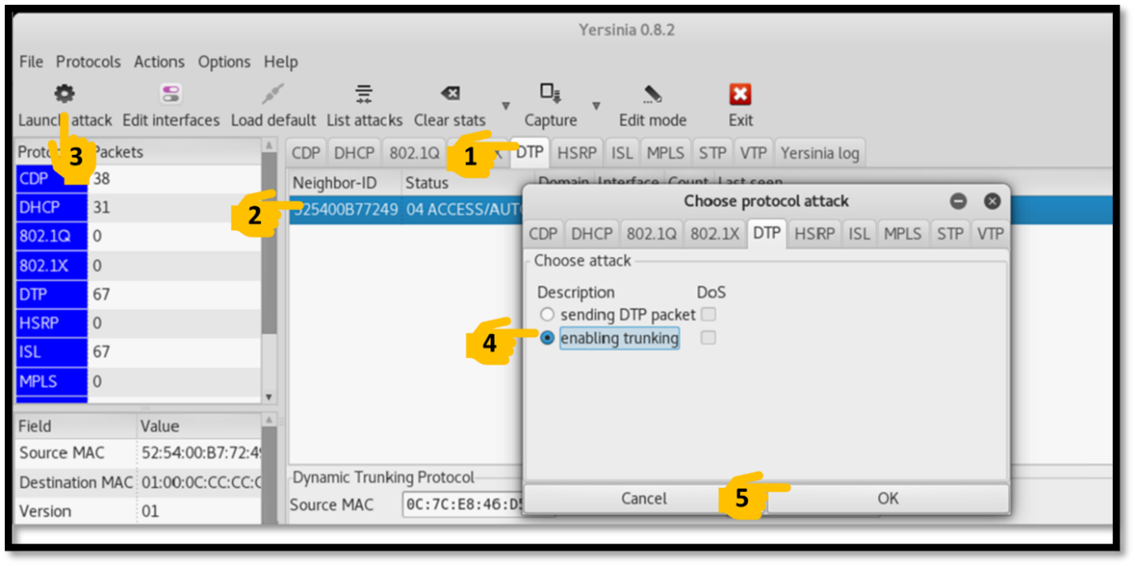
Step 5: Now open Switch console and verify trunk.
SW1#sh interface trunk
Port Mode Encapsulation Status Native vlan
Gi0/1 auto n-802.1q trunking 1
Port Vlans allowed on trunk
Gi0/1 1-4094
Port Vlans allowed and active in management domain
Gi0/1 1
Port Vlans in spanning tree forwarding state and not pruned
Gi0/1 1
SW1#
Now here we can see that Kali has successfully formed trunk with our switch. This gives kali access of all VLAN on that switch.
Task 2: Mitigate DTP Attack on Cisco Switch:
Step 1: Stop Yersinia on Kali Linux.
Step 2: To mitigate DTP attack we should first disable DTP from all the edge ports.
SW1#conf t
SW1(config)#int gi0/1
SW1(config-if)#switchport mode access
SW1(config-if)#switchport nonegotiate
SW1(config-if)#exit
Step 3: We will take access of kali machine, and again open “yersinia -G”.
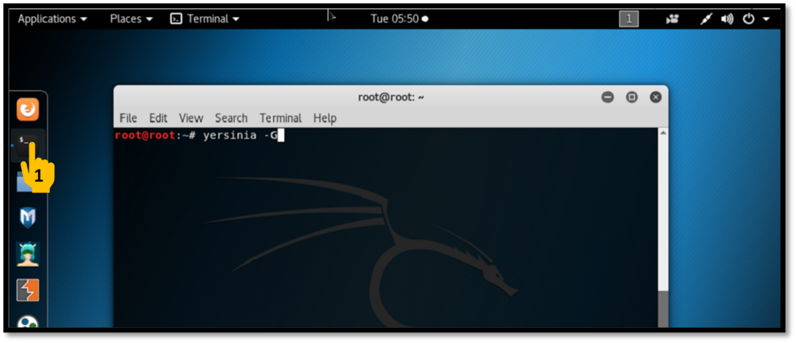
Step 4: Go to DTP Tab, here we will not see any DTP messages.
